**Project Requirement and Specification**

On

**SMART DUSTBIN - GARBAGE MANAGEMENT**

*(CSE core IV Semester Mini Project)*

*2021*



***Submitted by:***

*Doman Sarkar*

*(CSE-core-B-IV-Sem)*

*Roll. No.: 2014650*

*Session: 2019 - 2023*

*Class Roll No.: 23*

***Submitted to:***

*Mr. Ramesh Singh Rawat*

*(Mentor)*

***Guided by:***

*Mr. Deepak Uniyal*

*(Resource Person)*

**DEPARTMENT OF COMPUTER SCIENCE AND ENGINEERING**

**GRAPHIC ERA (Deemed to be University), DEHRADUN**

* 1. **About Project**

**Smart Dustbin – Garbage Management**

**Smart Dustbin** is a Dustbin or Waste-collector which contains some smart features like opening the lid automatically, show you the amount of collected garbage over the days, remind you to take out the trash every morning and can be controlled through your personal device or waiving at it.

The **motivation** of the project came from the fact that in this time we can have a device which can monitor the data of garbage collection and show it so that we can effectively use materials to manage our waste and the fact that physical contact is a main concern these days due to the current situation.

This device is a very good add-on in situations like the current pandemic where if you touch any surface you can get infected.

This device can be used in households as well as in other places where if anyone wants to throw some trash they don’t have to physically touch anything (like malls, hospitals, etc.) so it ensures that you are not getting infected or maybe someone wo is infected doesn’t know that they are infected and they touched the bin so you don’t have to touch it again.

This device is capable of storing data of all the collected levels of garbage day wise and it can display it so that you can keep track of it.

It also deploys an interactive web page so that anyone connected on the same network can control and see the data on the device without having to go to the device and see the display.

It can display stuff like messages or the weekly charted data so that if you don’t have a device which is connected to the same network then you can just glance over the screen.

The device can be powered with a power bank or with a simple 5v 500mA DC adapter. The whole code of the project is written in Embedded C and some percent consists of HTML programming.

**Project Features:**

* Automatic opening and closing of lid
* Garbage level detection
* Weekly statistical data
* Web interface for various features
* OLED screen for easy data representation
* Works with a normal 5v supply
  1. **Requirement of Project**
     1. **Hardware Requirement**

**Component** **Quantity**

* ESP8266 Wi-Fi (microcontroller) 01
* HC-SR04 (Ultrasonic sensor) 02
* SSD 1306 128x64 (OLED display) 01
* Servo 9gm 01
  + 1. **Software Requirement**
* Arduino IDE (1.8.14 or newer) ([link](https://www.arduino.cc/en/software))
* Lcd-image-converter ([link](https://sourceforge.net/projects/lcd-image-converter/files/lcd-image-converter-20190317.zip/download))
  + 1. **Connections**

**OLED ESP8266**

* VCC VCC
* GND GND
* SCL SCL
* SDA SDA

**HC-SR04** (hand detection) **ESP8266**

* VCC VCC
* GND VCC
* TRIG GPIO 02
* ECHO GPIO 0

**HC-SR04** (garbage level) **ESP8266**

* VCC VCC
* GND VCC
* TRIG GPIO 02
* ECHO GPIO 15

**Servo ESP8266**

* VCC VCC
* GND VCC
* PWM GPIO 13
  1. **Circuit Diagram**

**1.3.1 Circuit diagram with wirings:**

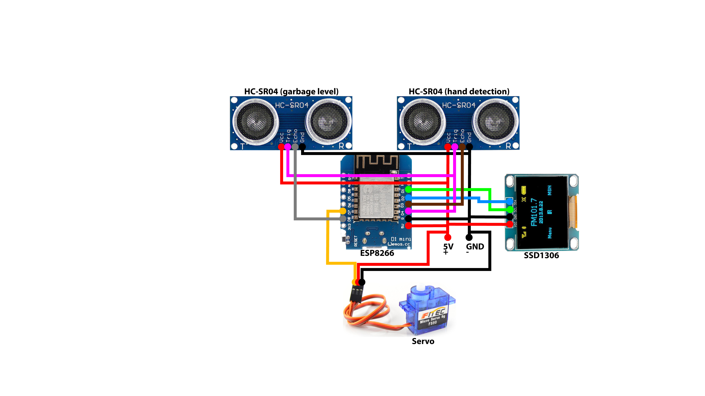

*Circuit diagram with wiring:-*

**1.3.2 Circuit diagram with color coded pins:**

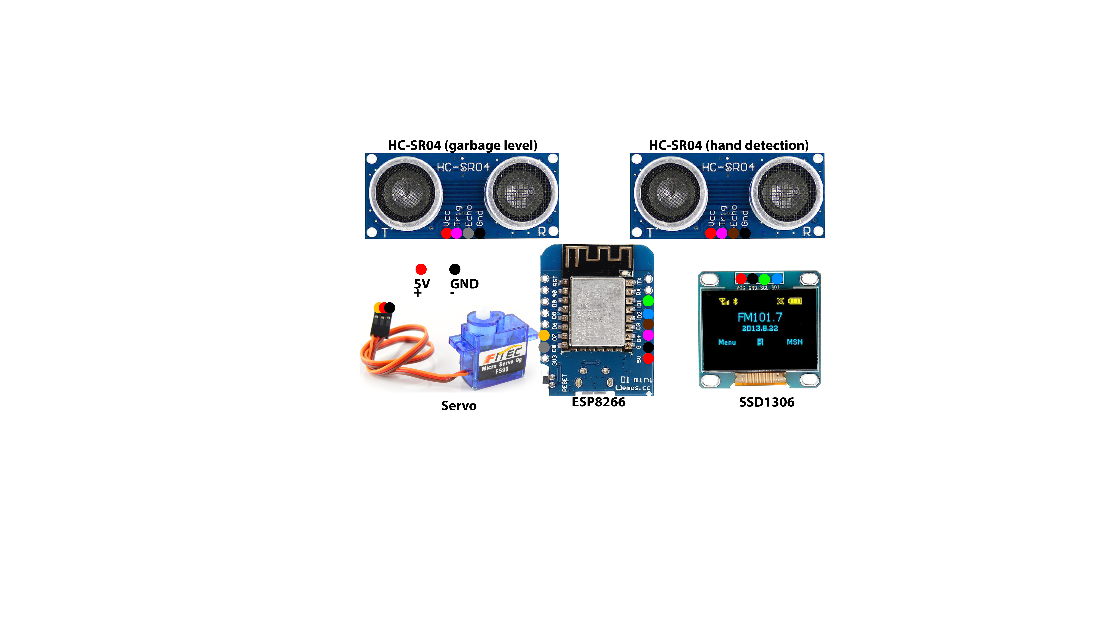

*Circuit diagram with color coded pins:-*

**1.4 Modules of Project**

* + 1. **Automatic hand detection**
* It uses the ultra-sonic sensors to measure the distance from the lid to any other object above it.
* If it detects an object less than 10cm from the lid then it opens the lid.
* After lid is opened it waits for some time so that user can throw the garbage.
* After lid is closed it waits for 2 seconds then it checks for the garbage level and saves the data and displays it.
  + 1. **Automatic Reminder**
* It uses a NTP server to get the day of week.
* If the day of week changes then it will remind you to take out the trash.
  + 1. **On device display**
* It can show many things like the startup screen, the connecting screen, open lid, close lid, collected data chart and reminders.
* It is very useful when you don’t have a wed connected device around.
  + 1. **Charts**
* It contains the data for garbage collected per week day.
* The chart level can go from 0 to 100 percent as it will only calculate in percentage.
  + 1. **Web interface**
* It uses a webpage to communicate to a user who is connected to the same network.
* The web page consists of two buttons “**OPEN**” and “**CALIBRATE**”.
* When the user presses “**OPEN**” The lid will open and monitor the garbage level.
* When the user presses “**CALIBRATE**” then the device will reset all the data from EEPROM and will reboot.
  + 1. **NTP**
* It is an online web server from which we can get real-time date and time info.
* It is used in the chart to allocate data in the right day of week column.
* It is used in the notification feature.
* As the day of week changes it shows you the notification.
* The current method updates the day of week after 60 seconds (1 minute).
  1. **Interfaces**
     1. **OLED display:-**
        1. *Startup Screen:*

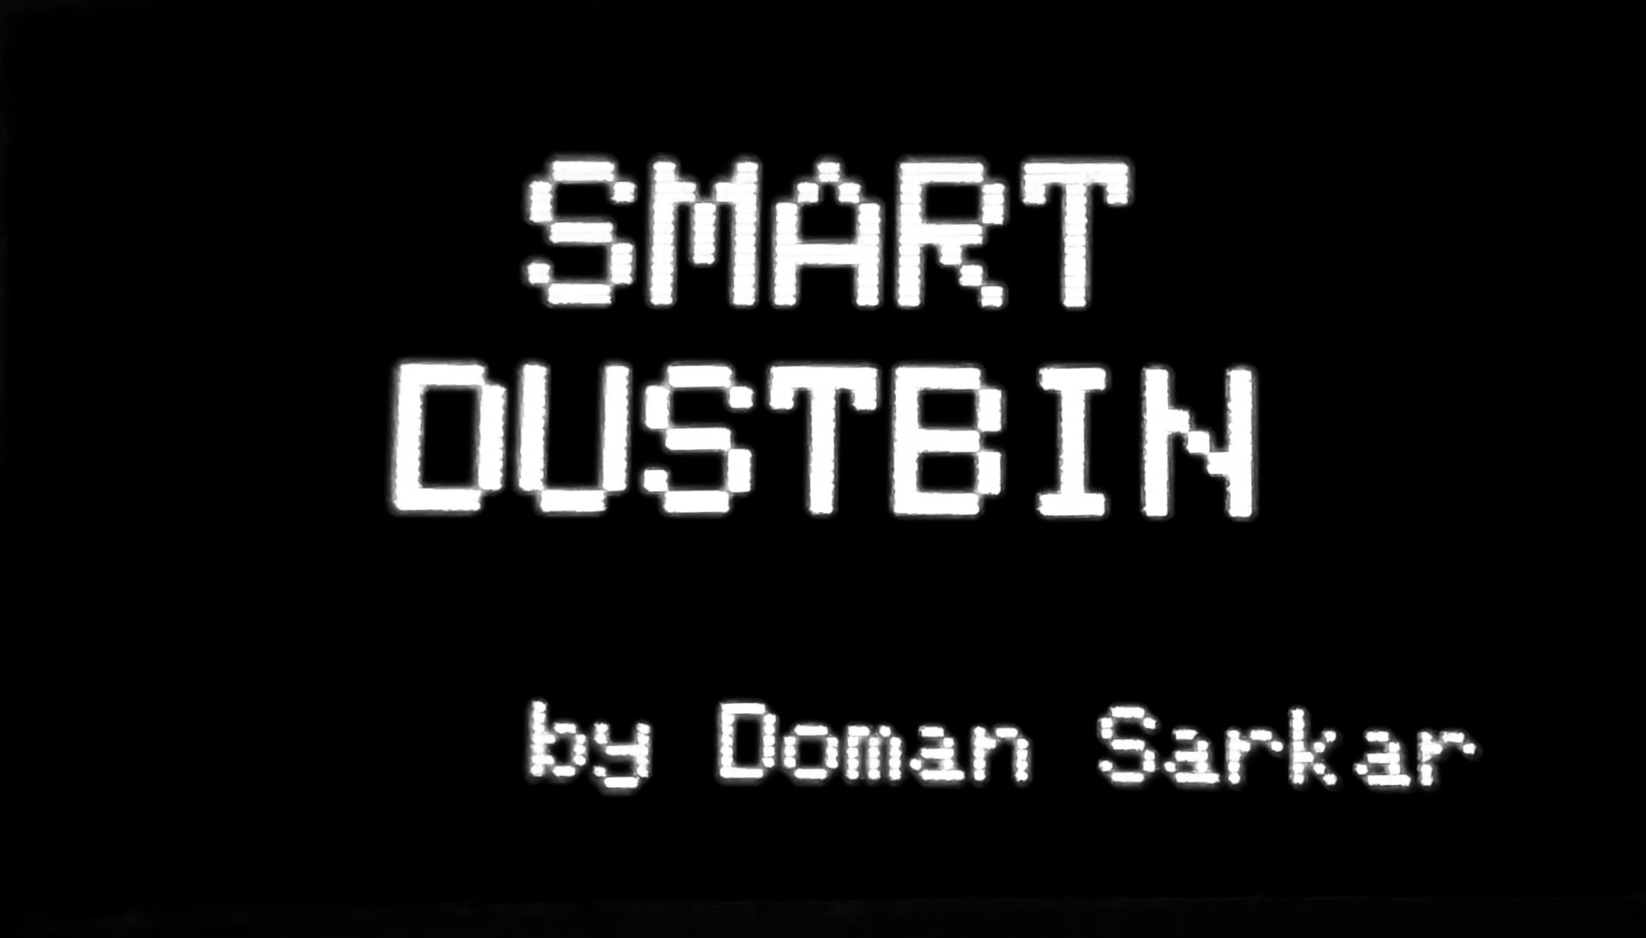

* + - 1. *Connecting Screen:*

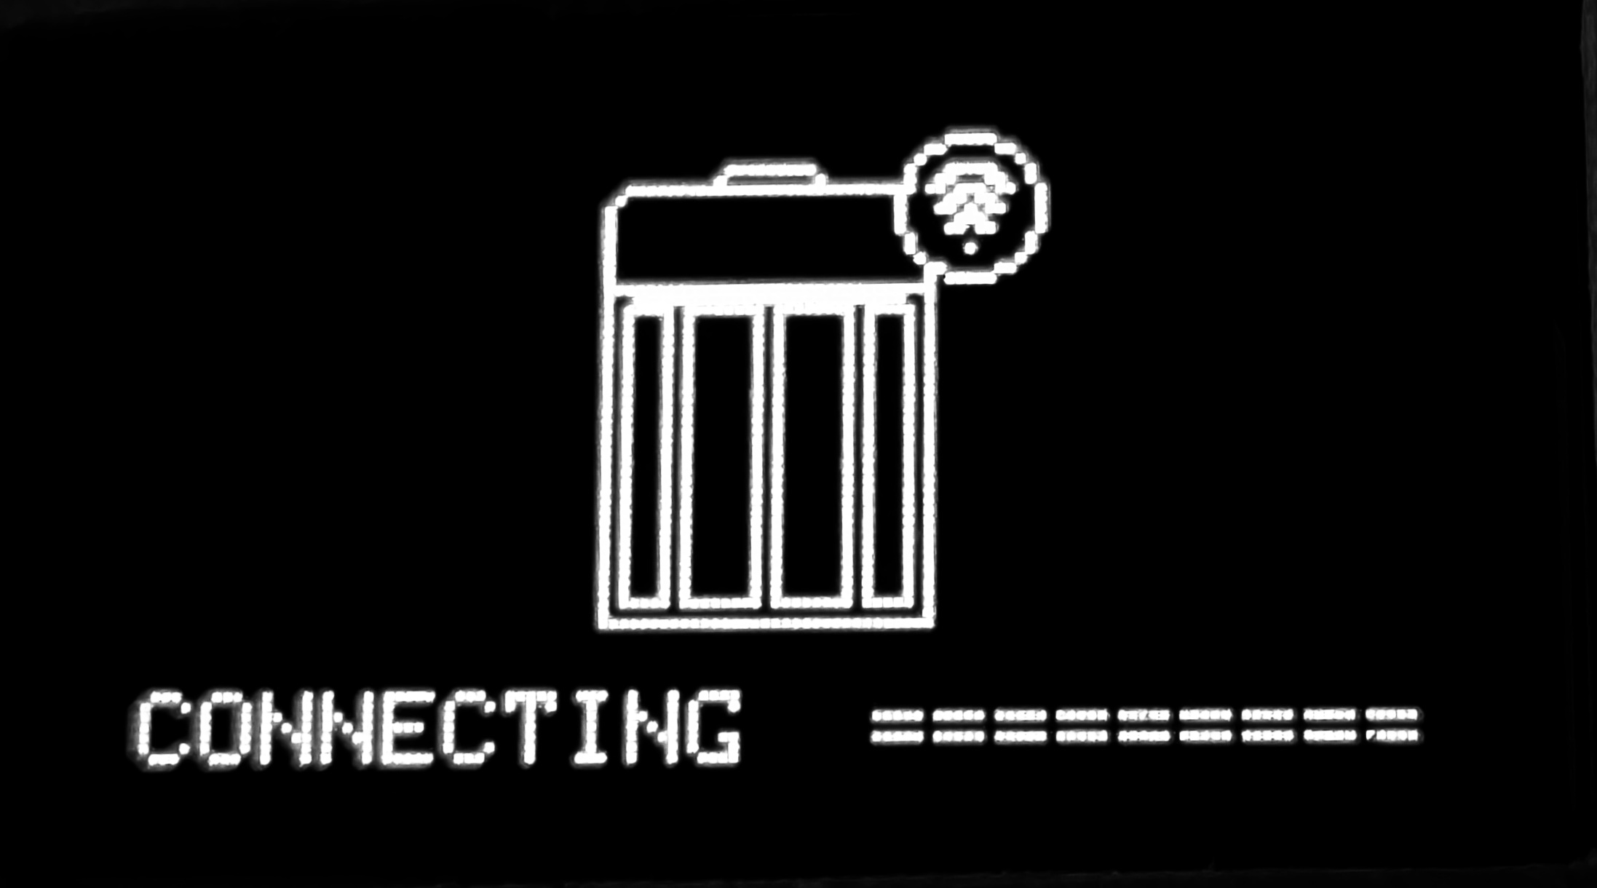

* + - 1. *Open lid:*

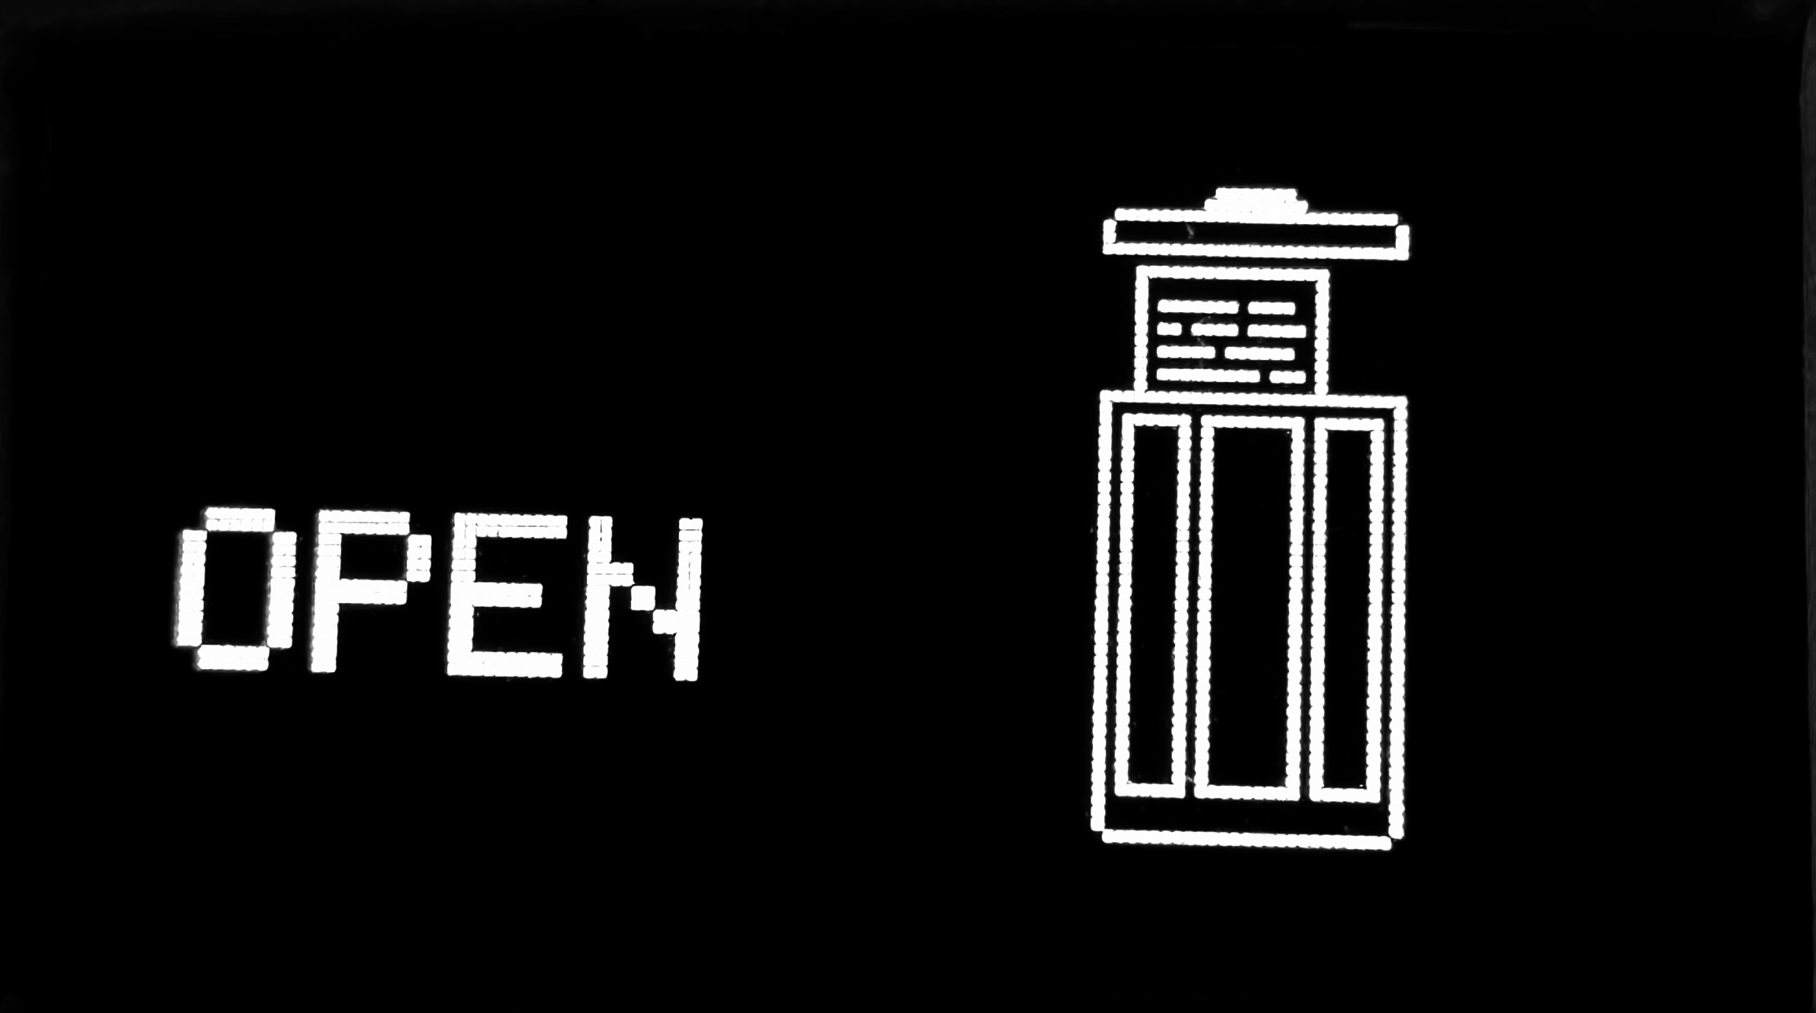

* + - 1. *Close lid:*



* + - 1. *Message:*

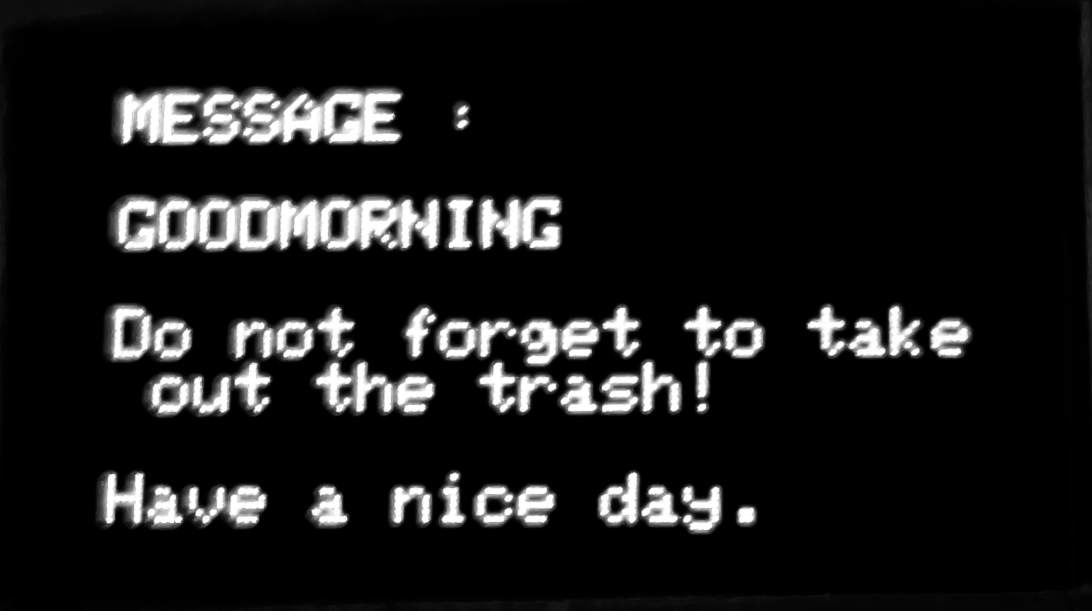

* + - 1. *Weekly chart:*

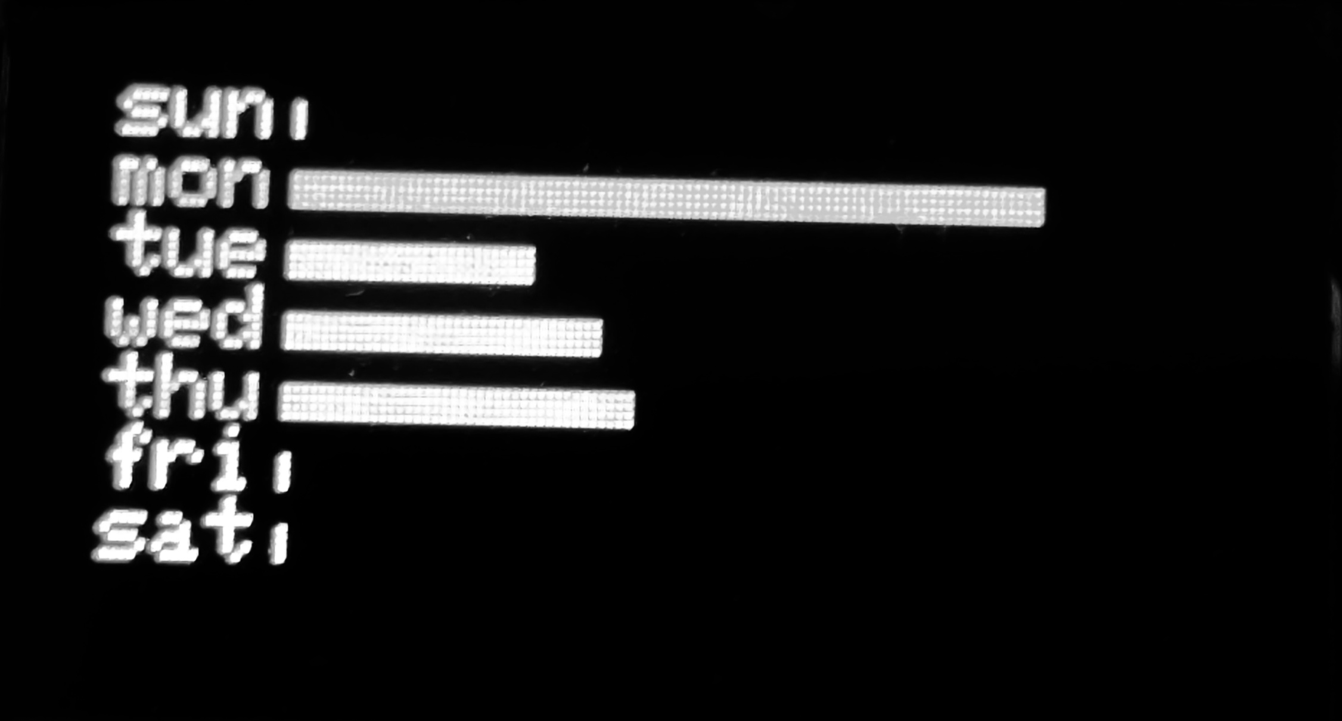

* + 1. **Webpage:-**
       1. *Default webpage:*

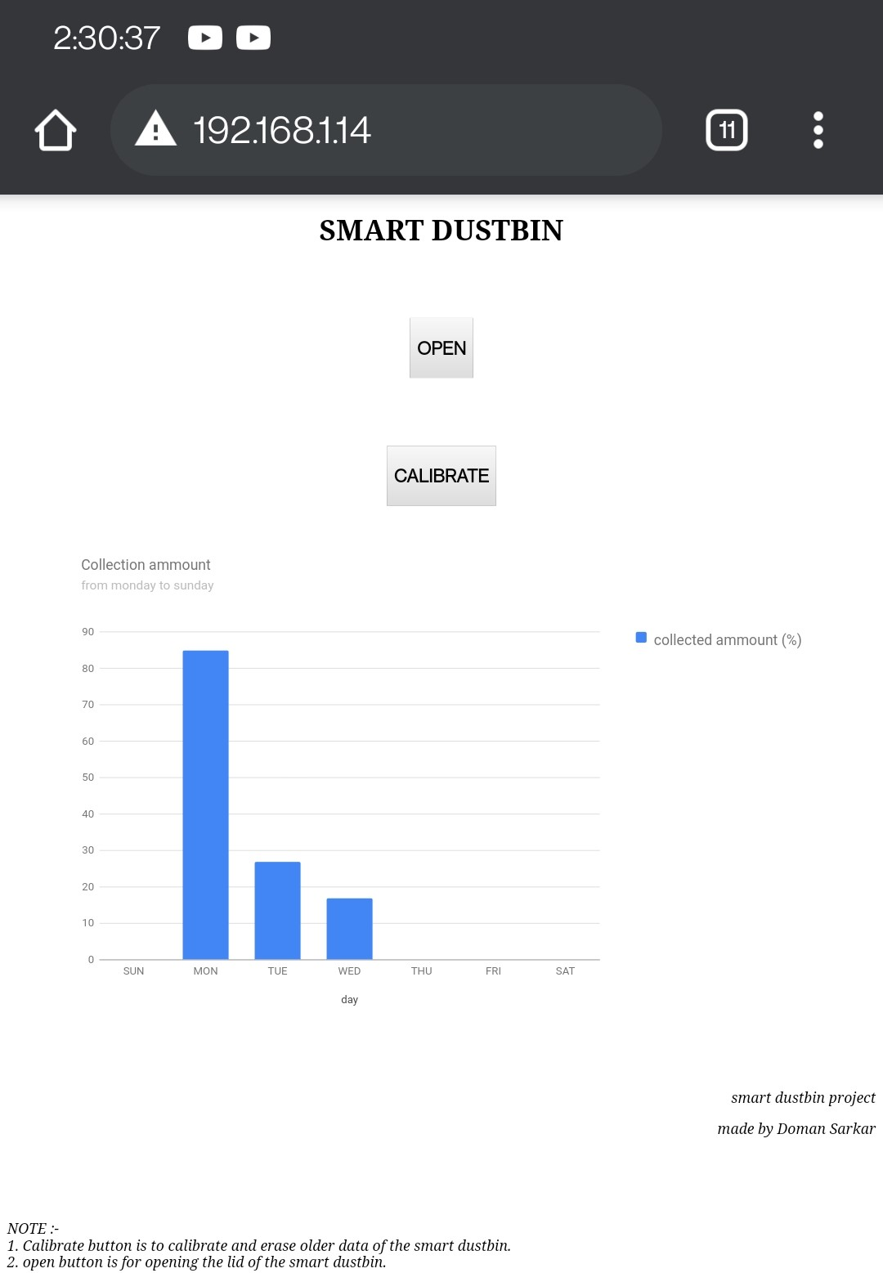

* + - 1. *Calibrate:*

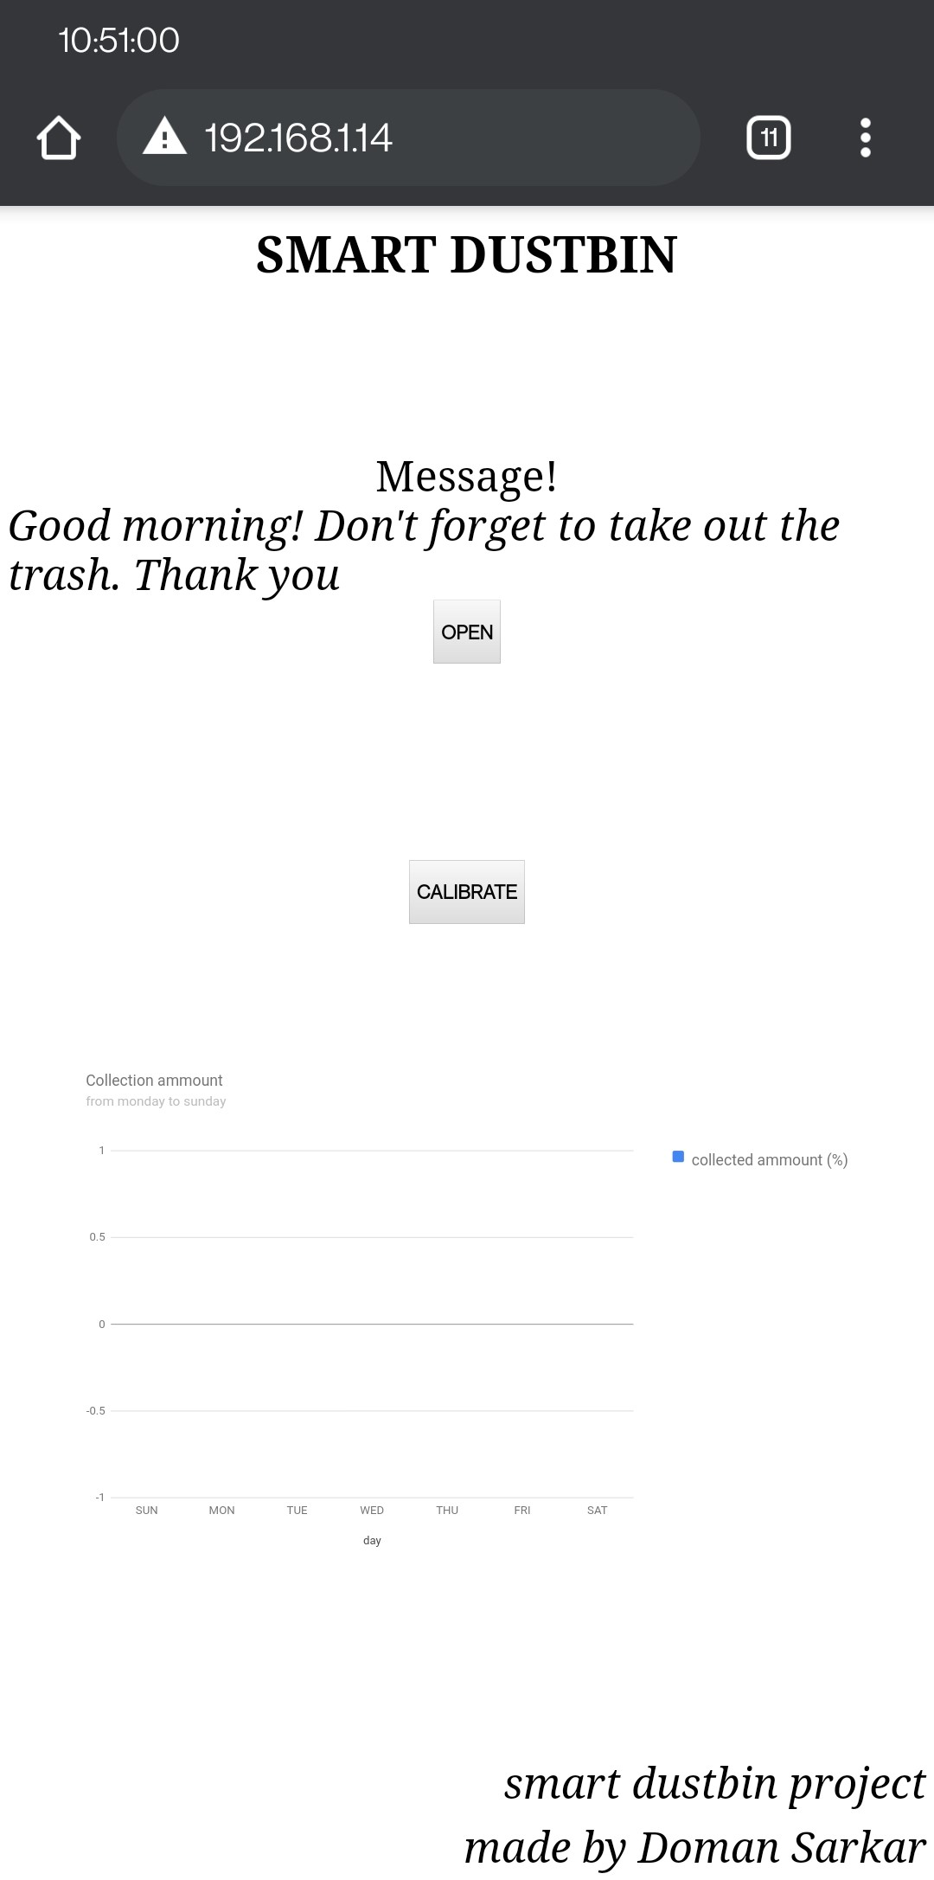

* 1. **NOTE**
     1. Change the “***ssid***” and “***password***” to your Wi-Fi SSID & password and “***canlen***” to the length of your garbage can in cm. The **IP address of the device** can be seen from the **serial monitor**.

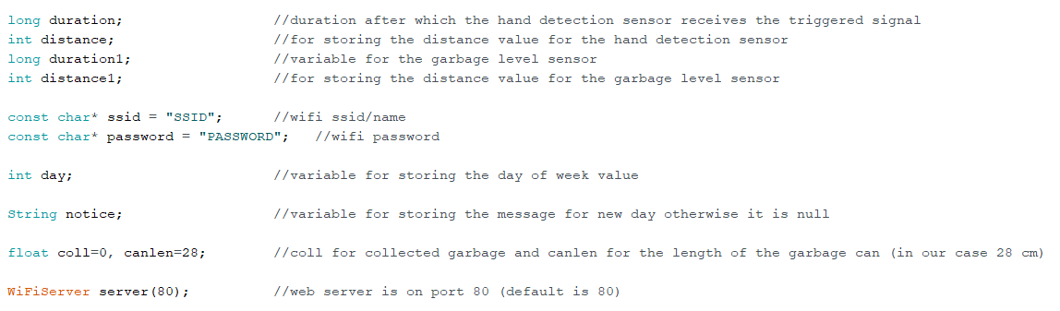

* + 1. Make sure you have Arduino IDE installed and have ESP boards installed.
    2. To install the ESP8266 board you need to go to “***File***” at the top left. Go to “***Preferences***” and in the “***Additional Boards Manager URLs:***” section paste the following link (use “***,***” to separate URLs).
    3. [*http://arduino.esp8266.com/stable/package_esp8266com_index.json*](http://arduino.esp8266.com/stable/package_esp8266com_index.json)

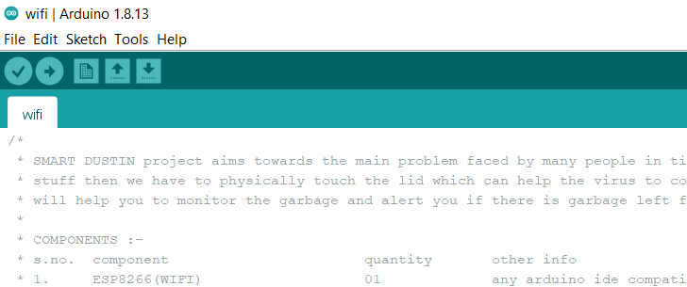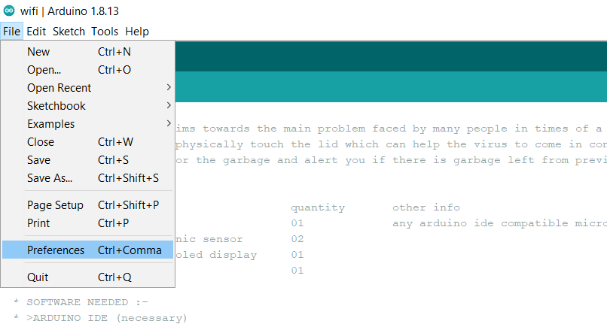

*Copy and paste the URL and click ok*

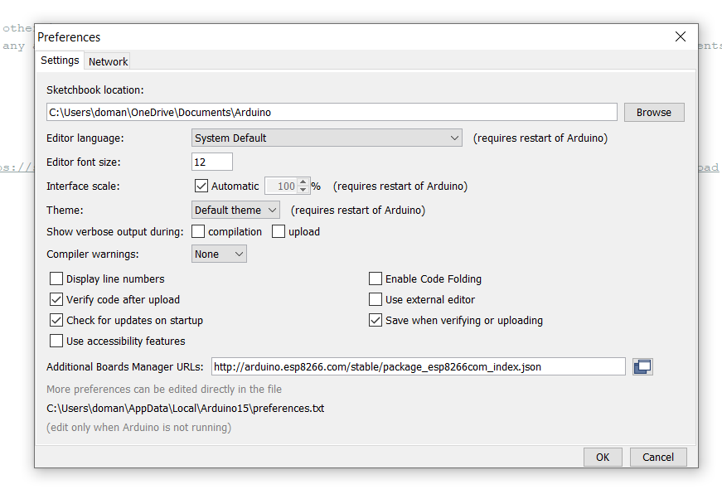

* + 1. After this wait for some time for the IDE to download and install the boards.
    2. After the board is installed go to “***Tools***” and then “***Board:***” and under the “***ESP8266 Boards***” select “***Generic ESP8266 Module***”.

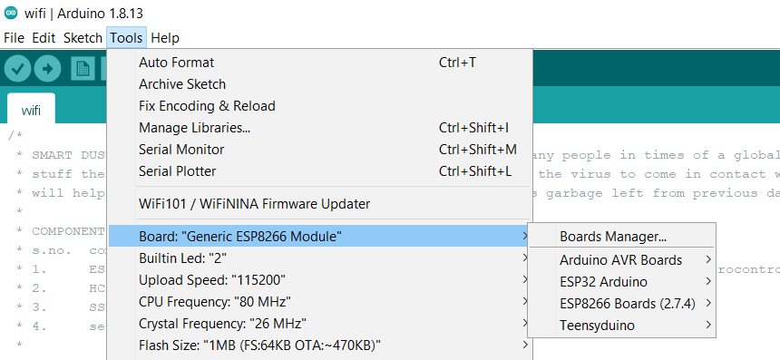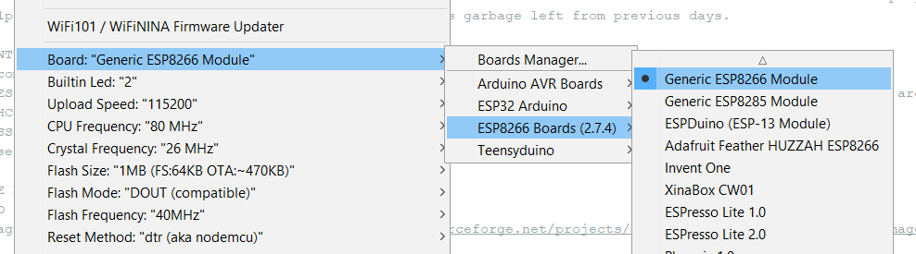

* + 1. After this go to “***Tools***” and select the “***Port***” on which the ESP8266 is connected.

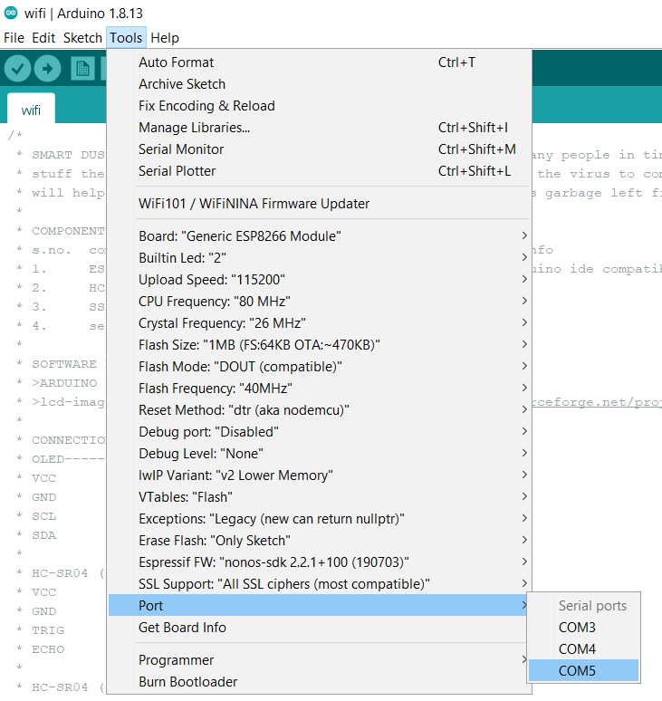

* + 1. Now go to “***Tools***” and “***Manage Libraries…***” after the “***Library Manager***” Loads completely on the search bar search and install the following libraries:
  + **NTPClient**  *by Fabrice Weinberg*
  + **Adafruit GFX Library** *by Adafruit*
  + **Adafruit SSD1306** *by Adafruit*

CV

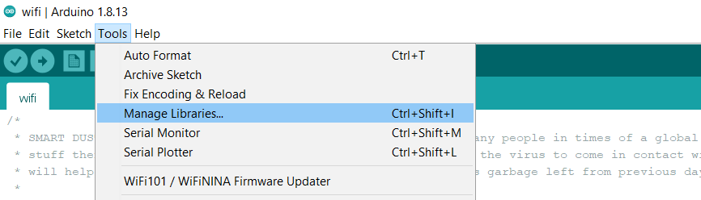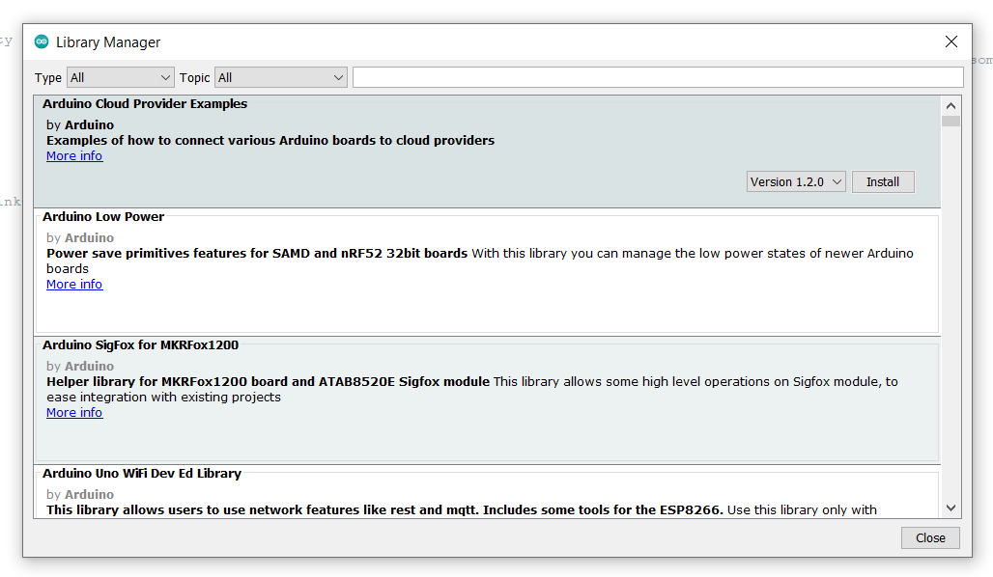

* + 1. After this you can upload the code and the IDE will automatically compile and upload the code.



**REFERENCES**

1. Quora: [www.quora.com](http://www.quora.com)
2. Stack Overflow: [www.stackoverflow.com](http://www.stackoverflow.com)
3. Arduino: [www.arduino.cc](http://www.arduino.cc)
4. NTP: [www.pool.ntp.org](http://www.pool.ntp.org)
5. Espressif: [www.espressif.com](http://www.espressif.com)